**Mentorship Program - Smart Assignment Engine**

Smart Assignment is a web-based application designed to streamline the process of assignment management and enhance collaboration among students, teachers, and administrators. This project aims to leverage web development technologies to create an intelligent platform that automates assignment creation, submission, grading, and feedback, thereby improving the efficiency and effectiveness of the assignment process. Students can access the platform to view and submit assignments. The application allows for secure file uploads, ensuring the integrity and confidentiality of submitted work. The system provides notifications and reminders to students about upcoming assignment due dates and any updates or clarifications from teachers.

Smart Assignment aims to enhance the assignment management process, promote collaboration, and improve educational outcomes. By leveraging intelligent technologies and providing a user-friendly interface, the application streamlines administrative tasks, enhances student-teacher communication, and facilitates a more efficient and engaging learning experience.

**Business requirements:**

To Address The Identified Business Problem, We Need To Create User Friendly Interface And Collaboration Features Between Teacher And Students Which Are Scalable And Accessible, student has to know the html, css, javascript and flask files

**Specify the business problem:** Existing Methods Involve Manual And Time-Consuming Tasks, Leading To Confusion, Missed Deadlines, And Limited Collaboration Opportunities Among Students, Teachers, And Administrators

**Social Impact**: It will make the life of a student on campus much easier. Professors also no need to carry the big pile of notebooks submitted by students and the transparency of marks allotment also will be there.  
  
**Business Model/Impact:**  It will also give a positive impression about the university around the time of admissions and can be made by digitizing the campus.

# **Technical Architecture:**

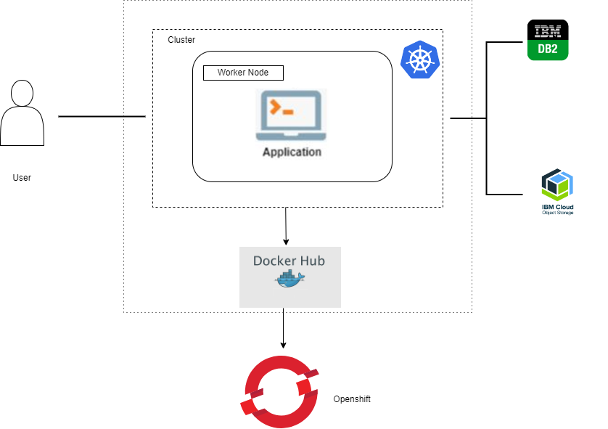

Business requirements of a smart assessment engine encompass several key aspects. Firstly, it should possess robust functionality to create, deliver, and evaluate assessments efficiently. This includes the ability to generate various question formats, support adaptive testing, and provide instant scoring and feedback to users. Secondly, it should offer seamless integration with existing learning management systems or platforms, enabling easy administration and data management. Additionally, the smart assessment engine should prioritise data security and privacy, ensuring the confidentiality and protection of sensitive user information. It should also have scalability to handle a large number of concurrent users and accommodate future growth. Furthermore, the engine should be adaptable and customizable to meet the unique needs of different educational institutions or organisations, allowing for personalised branding and tailored assessment experiences. Lastly, it should offer comprehensive analytics and reporting capabilities, enabling administrators to gain insights into performance trends, identify knowledge gaps, and make data-driven decisions to improve the assessment process and overall learning outcomes.

**Creating User Interfaces**

UserInterfaces:

User interfaces (UI) provide a way for users to interact with a system or application. They are designed to make it easy for users to access and control the functionality of a system. User interfaces play a critical role in the overall user experience by providing a way for users to interact with a system in a simple, efficient and effective manner.



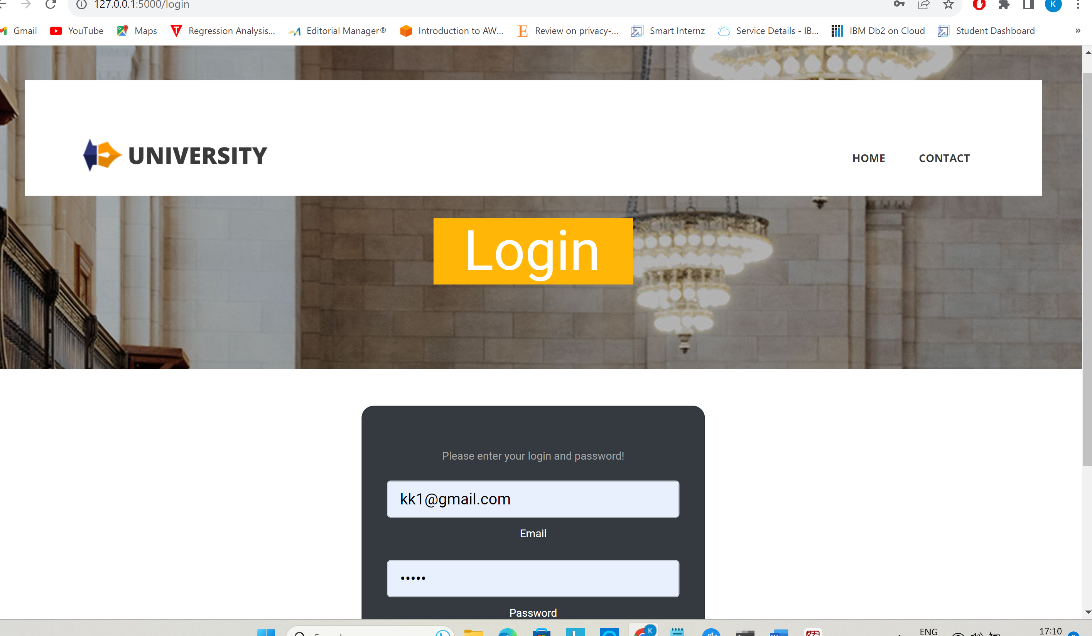

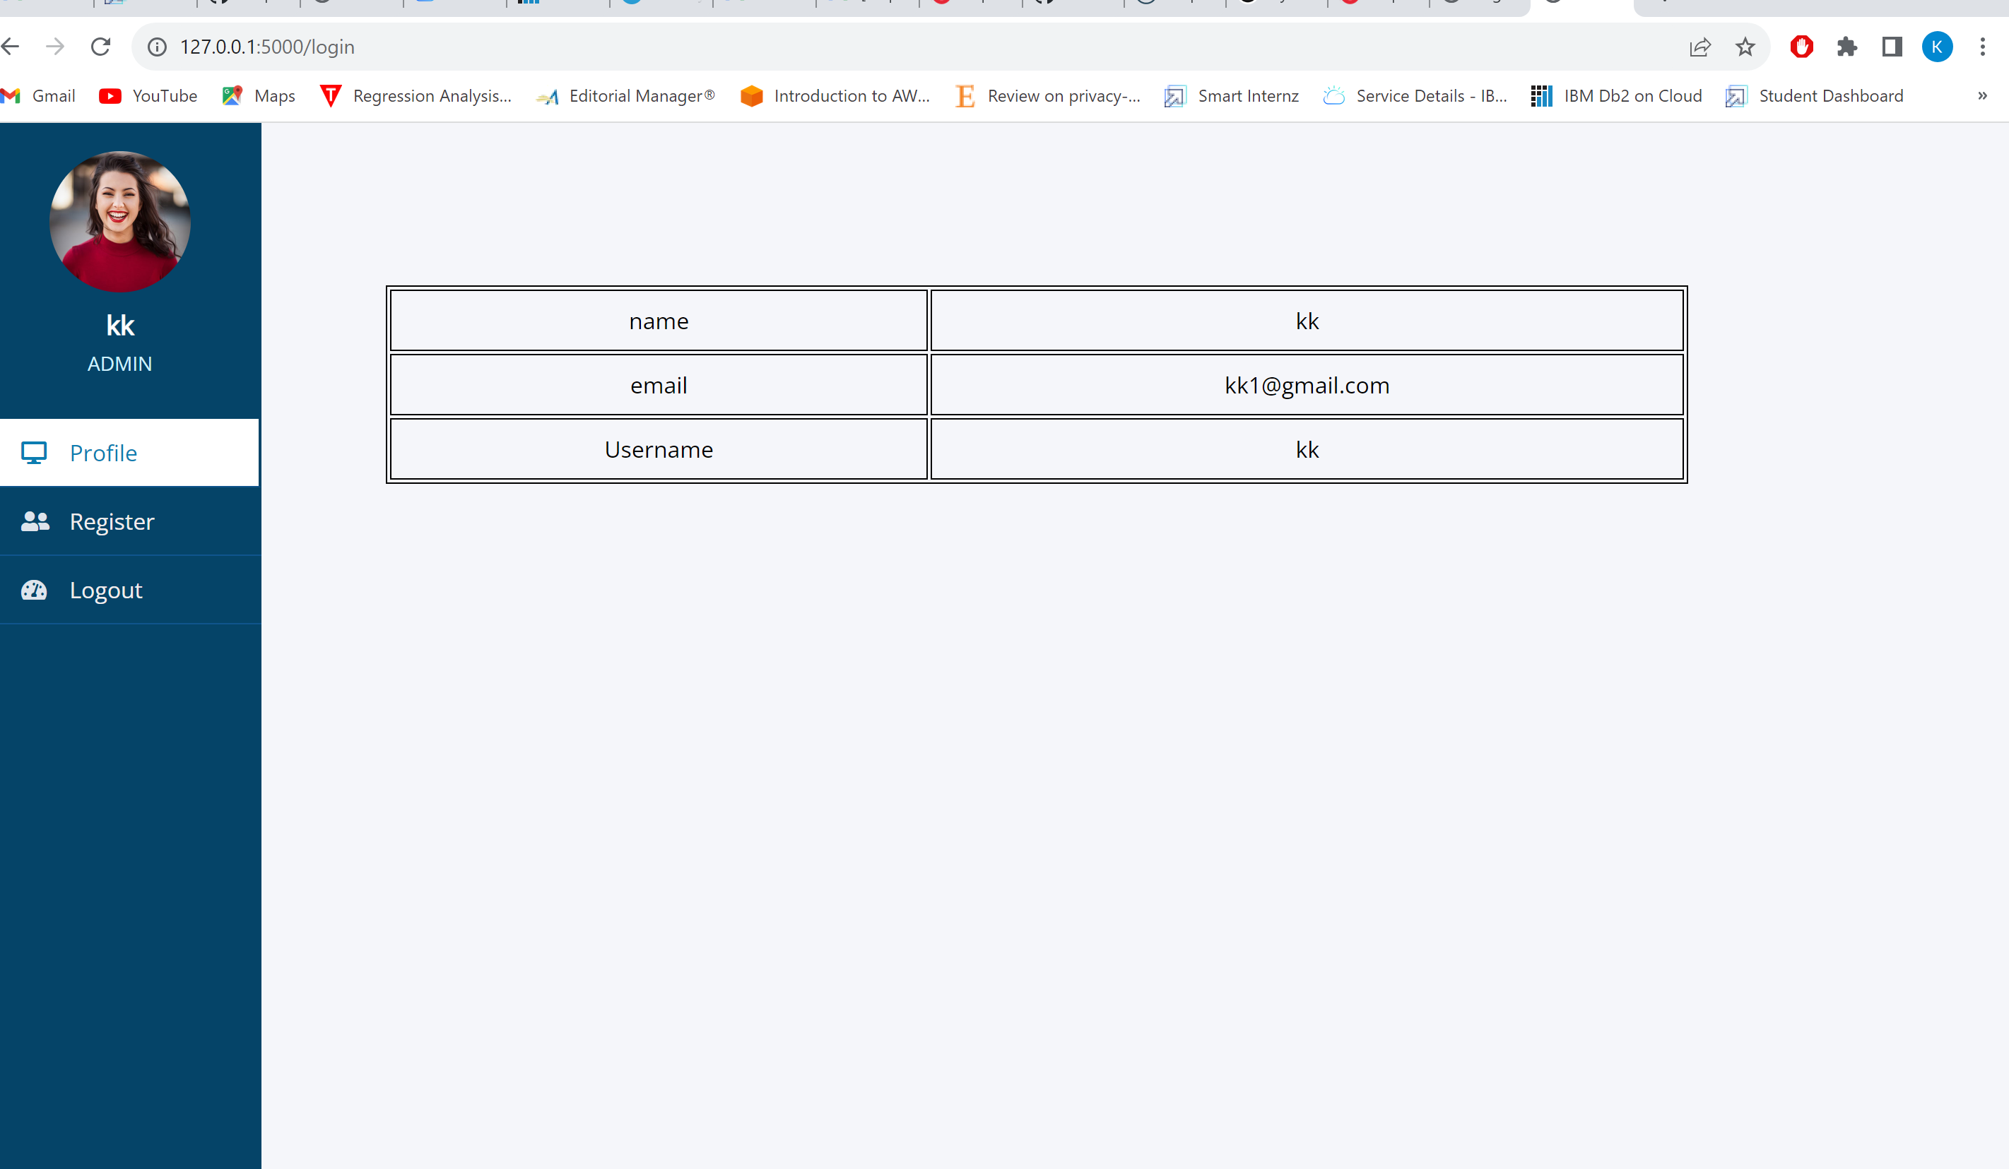

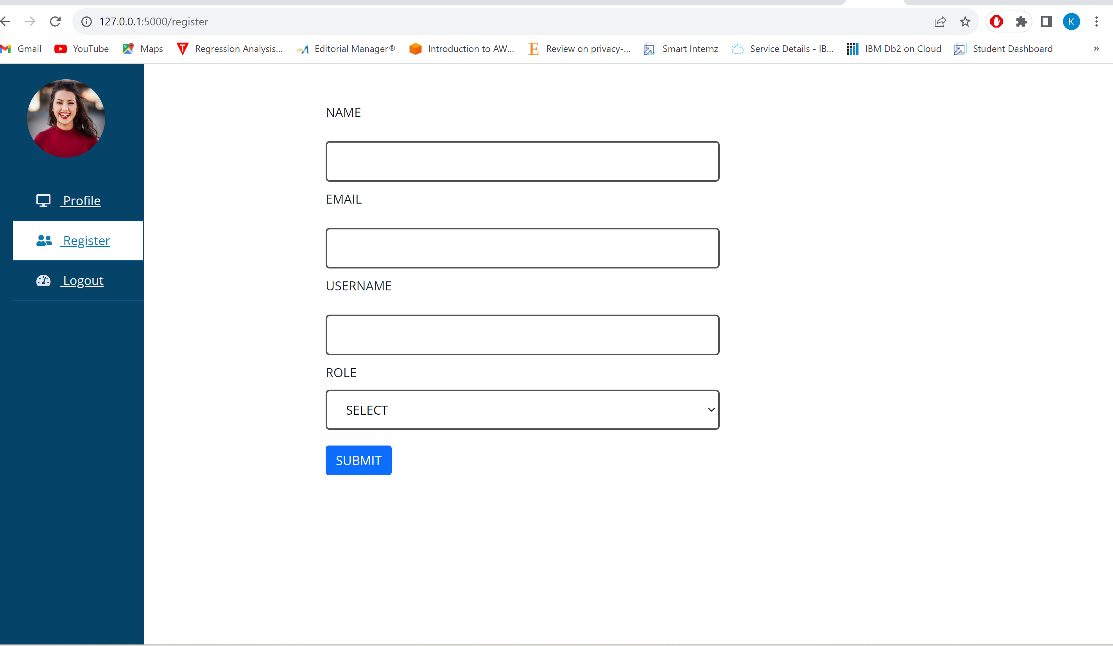

**Creating Database Connection**

Database connection

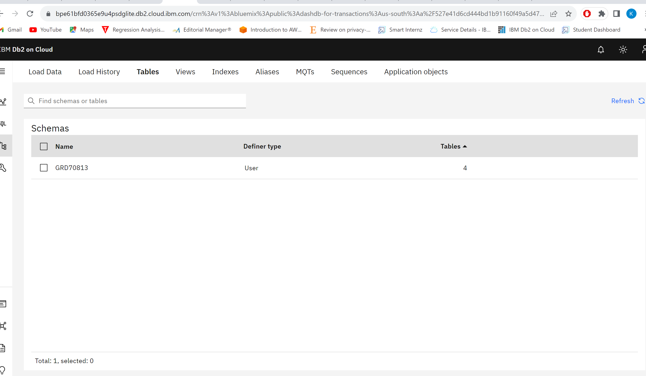

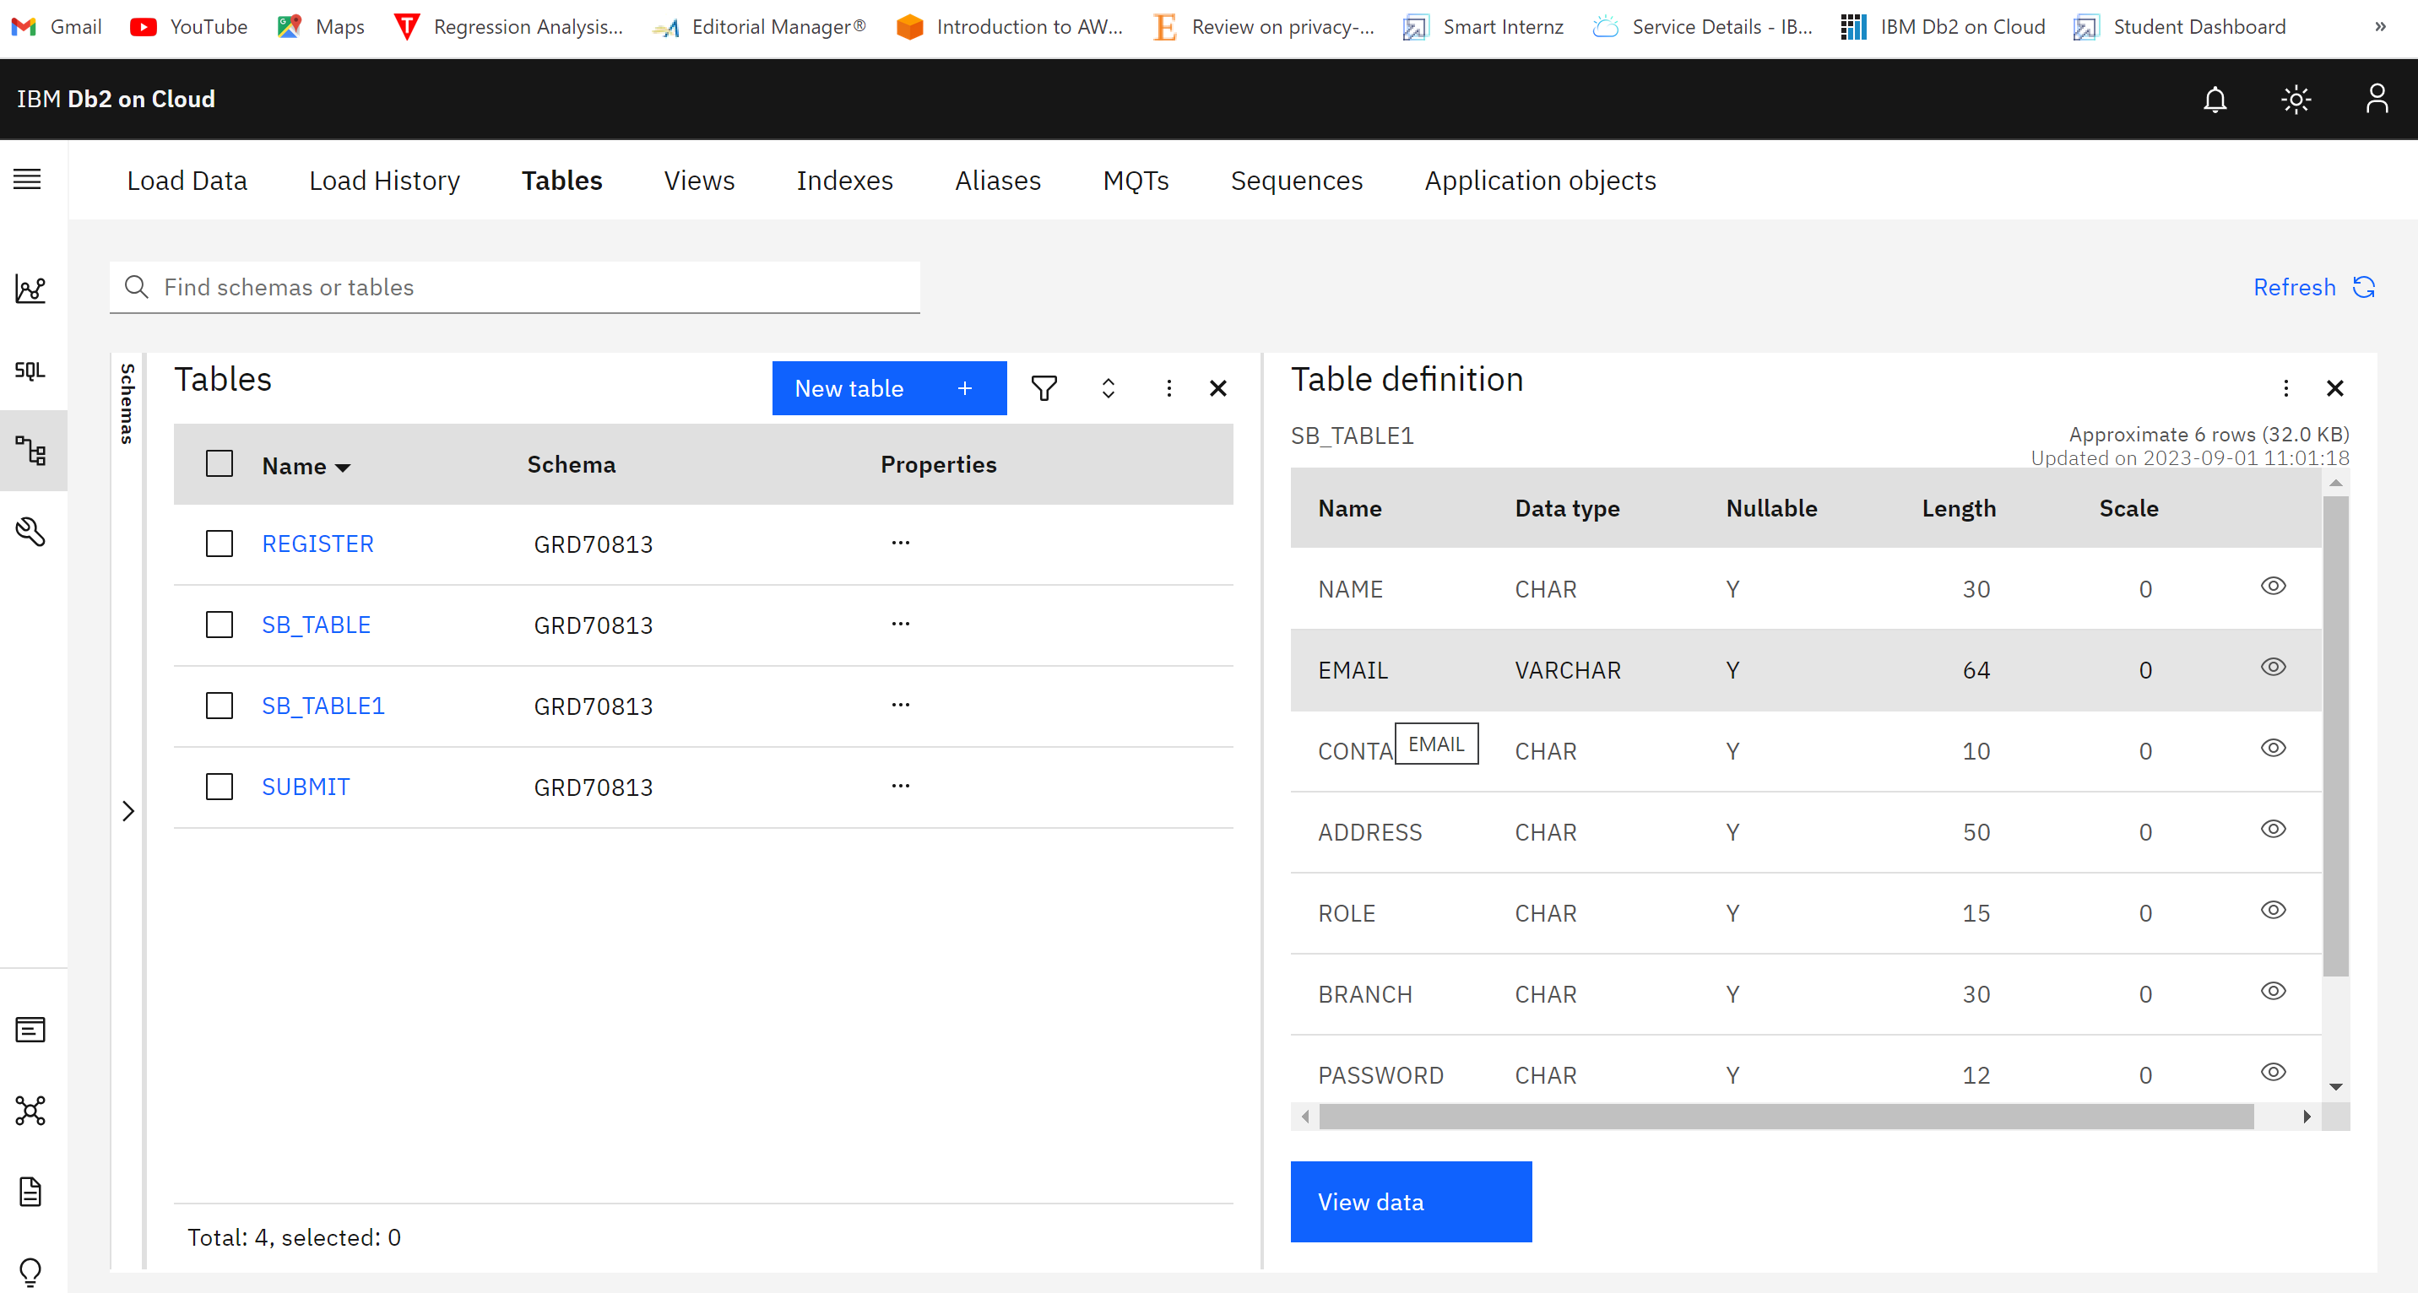

**Creating A Object Storage**

When you create an Object storage service, you will be redirected to the resources list. In that click on storage.

By makes use of cloud storage object we can store multimedia data

**Creating FLASK File**

from flask import Flask, render_template, request, session

import ibm_db

import ibm_boto3

from ibm_botocore.client import Config, ClientError

import os

import re

import random

import string

import datetime

import requests

app = Flask(__name__)

app.secret_key = 'a'

conn = ibm_db.connect("DATABASE=bludb; HOSTNAME=9938aec0-8105-433e-8bf9-0fbb7e483086.c1ogj3sd0tgtu0lqde00.databases.appdomain.cloud; PORT=32459; UID=grd70813;PASSWORD=4XbBD9IAngmyz5U5; SECURITY=SSL;SSLServerCertificate = DigiCertGlobalRootCA.crt", "", "")

url = "https://rapidprod-sendgrid-v1.p.rapidapi.com/mail/send"

@app.route("/")

def index():

return render_template("index.html")

@app.route("/index")

def index2():

return render_template("index.html")

@app.route("/about")

def about():

return render_template("about.html")

@app.route("/contact")

def contact():

return render_template("contact.html")

@app.route("/studentprofile")

def sprofile():

return render_template("studentprofile.html")

@app.route("/adminprofile")

def aprofile():

return render_template("adminprofile.html")

@app.route("/facultyprofile")

def fprofile():

return render_template("facultyprofile.html")

@app.route("/login", methods=['POST','GET'])

def loginentered():

global Userid

global Username

msg = ''

if request.method == "POST":

email = str(request.form['email'])

print(email)

password = request.form["password"]

sql = "SELECT * FROM SB_TABLE1 WHERE EMAIL=? AND PASSWORD=?" # from db2 sql table

stmt = ibm_db.prepare(conn, sql)

# this username & password is should be same as db-2 details & order also

ibm_db.bind_param(stmt, 1, email)

ibm_db.bind_param(stmt, 2, password)

ibm_db.execute(stmt)

account = ibm_db.fetch_assoc(stmt)

print(account)

if account:

session['Loggedin'] = True

session['id'] = account['EMAIL']

Userid = account['EMAIL']

session['email'] = account['EMAIL']

Username = account['NAME']

Name = account['NAME']

msg = "logged in successfully !"

sql = "SELECT ROLE FROM SB_TABLE1 where email = ?"

stmt = ibm_db.prepare(conn, sql)

ibm_db.bind_param(stmt, 1, email)

ibm_db.execute(stmt)

r = ibm_db.fetch_assoc(stmt)

print(r)

if r['ROLE'] == 1:

print("STUDENT")

return render_template("studentprofile.html", msg=msg, user=email, name = Name, role= "STUDENT", username=Username, email = email)

elif r['ROLE'] == 2:

print("FACULTY")

return render_template("facultyprofile.html", msg=msg, user=email, name = Name, role= "FACULTY", username=Username, email = email)

else:

return render_template('adminprofile.html', msg=msg, user=email, name = Name, role= "ADMIN", username=Username, email = email)

else:

msg = "Incorrect Email/password"

return render_template("login.html", msg=msg)

else:

return render_template("login.html")

@app.route("/register", methods=['POST', 'GET'])

def signup():

msg = ''

if request.method == 'POST':

name = request.form["sname"]

email = request.form["semail"]

username = request.form["susername"]

role =int(request.form['role'])

password = ''.join(random.choice(string.ascii_letters) for i in range(0,8))

link = 'https://mahidharuniversity.ac.in/portal'

print(password)

sql = "SELECT* FROM sb_table1 WHERE email= ?"

stmt = ibm_db.prepare(conn, sql)

ibm_db.bind_param(stmt, 1, email)

ibm_db.execute(stmt)

account = ibm_db.fetch_assoc(stmt)

print(account)

if account:

msg = "Already Registered"

return render_template('adminregister.html', error=True, msg=msg)

elif not re.match(r'[^@]+@[^@]+\.[^@]+', email):

msg = "Invalid Email Address!"

else:

insert_sql = "INSERT INTO sb_table1 VALUES (?,?,?,?,?)"

prep_stmt = ibm_db.prepare(conn, insert_sql)

# this username & password is should be same as db-2 details & order also

ibm_db.bind_param(prep_stmt, 1, name)

ibm_db.bind_param(prep_stmt, 2, email)

ibm_db.bind_param(prep_stmt, 8, username)

ibm_db.bind_param(prep_stmt, 5, role)

ibm_db.bind_param(prep_stmt, 7, password)

ibm_db.execute(prep_stmt)

payload = {

"personalizations": [

{

"to": [{"email": email}],

"subject": "Student Account Details"

}

],

"from": {"email": "mahidhar@thesmartbridge.com"},

"content": [

{

"type": "text/plain",

"value": "Dear {} , \n Welcome to Mahidhar University, Here there the details to Login Into your student portal link : {} \n YOUR Username : {} \n PASSWORD : {} \n Thank you \n Sincerely\n Office of Admissions\n Mahidhar Institute of Technology \n E-Mail: admission@mahidharuniversity.ac.in ; Website: www.mahidharuniversity.ac.in" .format( name,link, username, password)

}

]

}

headers = {

"content-type": "application/json",

"X-RapidAPI-Key": "714250c24fmsh829f65c05932f01p1ad65cjsn43a39e64b3bb",

"X-RapidAPI-Host": "rapidprod-sendgrid-v1.p.rapidapi.com"

}

response = requests.request("POST", url, json=payload, headers=headers)

print(response.text)

msg = "Registration Successful"

return render_template('adminregister.html', msg=msg)

@app.route("/studentsubmit", methods=['POST','GET'])

def sassignment():

u = Username.strip()

subtime = []

ma = []

sql = "SELECT SUBMITTIME, MARKS from SUBMIT WHERE STUDENTNAME = ? "

stmt = ibm_db.prepare(conn, sql)

ibm_db.bind_param(stmt, 1, u)

ibm_db.execute(stmt)

st = ibm_db.fetch_tuple(stmt)

while st !=False:

subtime.append(st[0])

ma.append(st[1])

st = ibm_db.fetch_tuple(stmt)

print(subtime)

print(ma)

if request.method=="POST":

for x in range (1,5):

x = str(x)

y = str("file"+x)

print(type(y))

f=request.files[ y ]

print(f)

print(f.filename)

if f.filename != '':

basepath=os.path.dirname(__file__) #getting the current path i.e where app.py is present

#print("current path",basepath)

filepath=os.path.join(basepath,'uploads',u+x+".pdf") #from anywhere in the system we can give image but we want that image later to process so we are saving it to uploads folder for reusing

#print("upload folder is",filepath)

f.save(filepath)

# connecting with cloud object storage

COS_ENDPOINT = "https://s3.jp-tok.cloud-object-storage.appdomain.cloud"

COS_API_KEY_ID = "feQ_YXP6d0HktdnQwEH6YFh545ZpgacGGQJkguFhthrb"

COS_INSTANCE_CRN = "crn:v1:bluemix:public:cloud-object-storage:global:a/2396b07efb5e497894432383c651d668:2883dbef-d638-4e0a-922e-2ad686a7ad08::"

cos = ibm_boto3.resource("s3",ibm_api_key_id=COS_API_KEY_ID,ibm_service_instance_id=COS_INSTANCE_CRN, config=Config(signature_version="oauth"),endpoint_url=COS_ENDPOINT)

cos.meta.client.upload_file(Filename= filepath,Bucket='studentassignmentsb',Key= u+x+".pdf")

msg = "Uploding Successful"

ts = datetime.datetime.now()

t = ts.strftime("%Y-%m-%d %H:%M:%S")

sql1 = "SELECT * FROM SUBMIT WHERE STUDENTNAME = ? AND ASSIGNMENTNUM = ?"

stmt = ibm_db.prepare(conn, sql1)

ibm_db.bind_param(stmt, 1, u)

ibm_db.bind_param(stmt, 2, x)

ibm_db.execute(stmt)

acc = ibm_db.fetch_assoc(stmt)

print(acc)

if acc == False:

sql = "INSERT into SUBMIT (STUDENTNAME, ASSIGNMENTNUM, SUBMITTIME) values (?,?,?)"

stmt = ibm_db.prepare(conn, sql)

ibm_db.bind_param(stmt, 1, u)

ibm_db.bind_param(stmt, 2, x)

ibm_db.bind_param(stmt, 3, t)

ibm_db.execute(stmt)

else:

sql = "UPDATE SUBMIT SET SUBMITTIME = ? WHERE STUDENTNAME = ? and ASSIGNMENTNUM = ?"

stmt = ibm_db.prepare(conn, sql)

ibm_db.bind_param(stmt, 1, t)

ibm_db.bind_param(stmt, 2, u)

ibm_db.bind_param(stmt, 3, x)

ibm_db.execute(stmt)

return render_template("studentsubmit.html", msg=msg, datetime=subtime, Marks=ma)

return render_template("studentsubmit.html", datetime=subtime, Marks=ma)

@app.route("/facultymarks")

def facultymarks():

data=[]

sql = "SELECT USERNAME from SB_TABLE1 WHERE ROLE=1"

stmt = ibm_db.prepare(conn, sql)

ibm_db.execute(stmt)

name = ibm_db.fetch_tuple(stmt)

while name!= False:

data.append(name)

name=ibm_db.fetch_tuple(stmt)

data1 = []

for i in range(0,len(data)):

y = data[i][0].strip()

data1.append(y)

data1 = set(data1)

data1 = list(data1)

print(data1)

return render_template("facultystulist.html", names = data1, le=len(data1))

@app.route("/marksassign/<string:stdname>", methods=['POST', 'GET'])

def marksassign(stdname):

global u

global g

global file

da = []

COS_ENDPOINT = "https://s3.jp-tok.cloud-object-storage.appdomain.cloud"

COS_API_KEY_ID = "feQ_YXP6d0HktdnQwEH6YFh545ZpgacGGQJkguFhthrb"

COS_INSTANCE_CRN = "crn:v1:bluemix:public:cloud-object-storage:global:a/2396b07efb5e497894432383c651d668:2883dbef-d638-4e0a-922e-2ad686a7ad08::"

cos = ibm_boto3.client("s3",

ibm_api_key_id=COS_API_KEY_ID,

ibm_service_instance_id=COS_INSTANCE_CRN,

config=Config(signature_version="oauth"),

endpoint_url=COS_ENDPOINT)

output = cos.list_objects(Bucket="studentassignmentsb")

output

l=[]

for i in range(0,len(output['Contents'])):

j = output['Contents'][i]['Key']

l.append(j)

l

u = stdname

print(len(u))

print(len(l))

n = []

for i in range(0,len(l)):

for j in range(0,len(u)):

if u[j]==l[i][j]:

n.append(l[i])

file = set(n)

file = list(file)

print(file)

print(len(file))

g = len(file)

sql = "SELECT SUBMITTIME from SUBMIT WHERE STUDENTNAME=?"

stmt = ibm_db.prepare(conn, sql)

ibm_db.bind_param(stmt , 1, u)

ibm_db.execute(stmt)

m = ibm_db.fetch_tuple(stmt)

while m != False:

da.append(m[0])

m = ibm_db.fetch_tuple(stmt)

print(da)

return render_template("facultymarks.html", file=file, g=g, marks=0, datetime=da)

@app.route("/marksupdate/<string:anum>", methods=['POST', 'GET'])

def marksupdate(anum):

ma = []

da = []

mark = request.form['mark']

print(mark)

print(u)

sql = "UPDATE SUBMIT SET MARKS = ? WHERE STUDENTNAME = ? and ASSIGNMENTNUM = ?"

stmt = ibm_db.prepare(conn, sql)

ibm_db.bind_param(stmt, 1, mark)

ibm_db.bind_param(stmt, 2, u)

ibm_db.bind_param(stmt, 3, anum)

ibm_db.execute(stmt)

msg = "MARKS UPDATED"

sql = "SELECT MARKS, SUBMITTIME from SUBMIT WHERE STUDENTNAME=?"

stmt = ibm_db.prepare(conn, sql)

ibm_db.bind_param(stmt , 1, u)

ibm_db.execute(stmt)

m = ibm_db.fetch_tuple(stmt)

while m != False:

ma.append(m[0])

da.append(m[1])

m = ibm_db.fetch_tuple(stmt)

#ma = ma[0]

print(ma)

print(da)

return render_template("facultymarks.html", msg =msg, marks = ma, g=g, file=file, datetime=da)

@app.route("/logout")

def logout():

session.pop('loggedin', None)

session.pop('id', None)

session.pop('username', None)

return render_template("logout.html")

if __name__ == "__main__":

app.run(debug=True, host="0.0.0.0")

**Containerize Your Application**

Containerization is a method of packaging and deploying software applications in a way that allows them to run consistently across different environments. Containers are a lightweight alternative to virtual machines and are used to package and deploy applications as self-contained units.

The main advantage of containerization is that it allows for more efficient use of resources and greater flexibility in terms of deployment. Containers are isolated from one another, meaning that they can run on the same host without interfering with each other. This allows for multiple applications to be run on the same machine, which can save on hardware costs

Docker File:

Docker Desktop

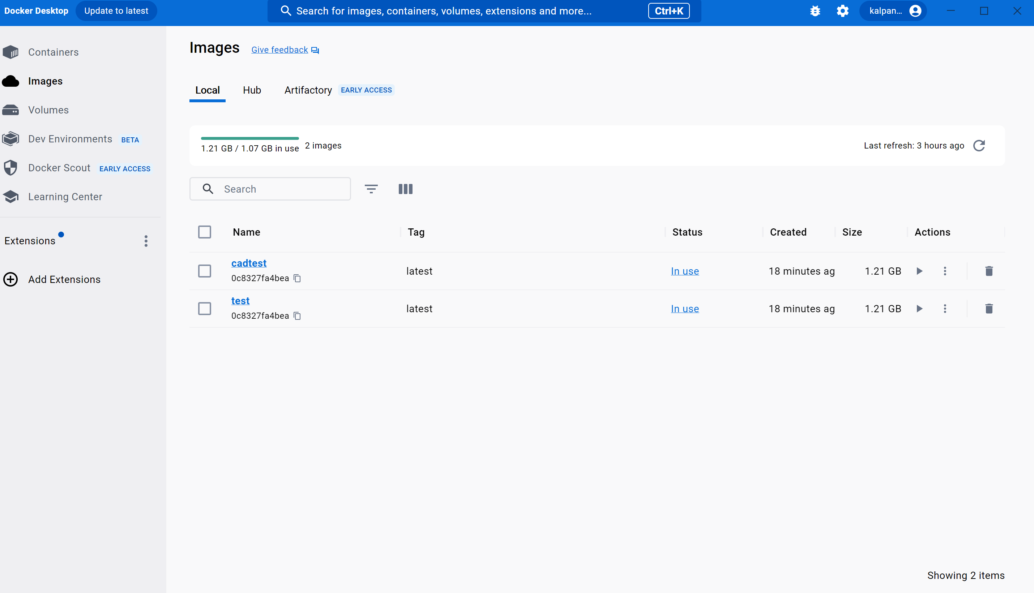

Creation of docker image:

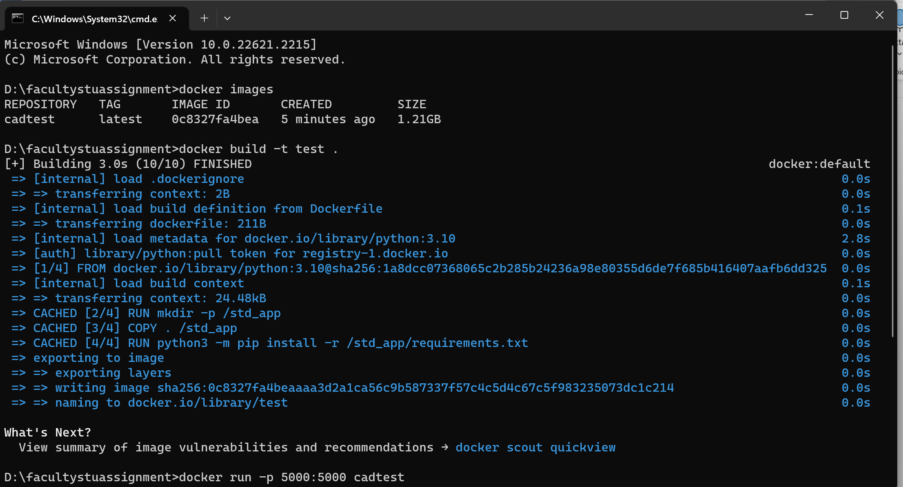

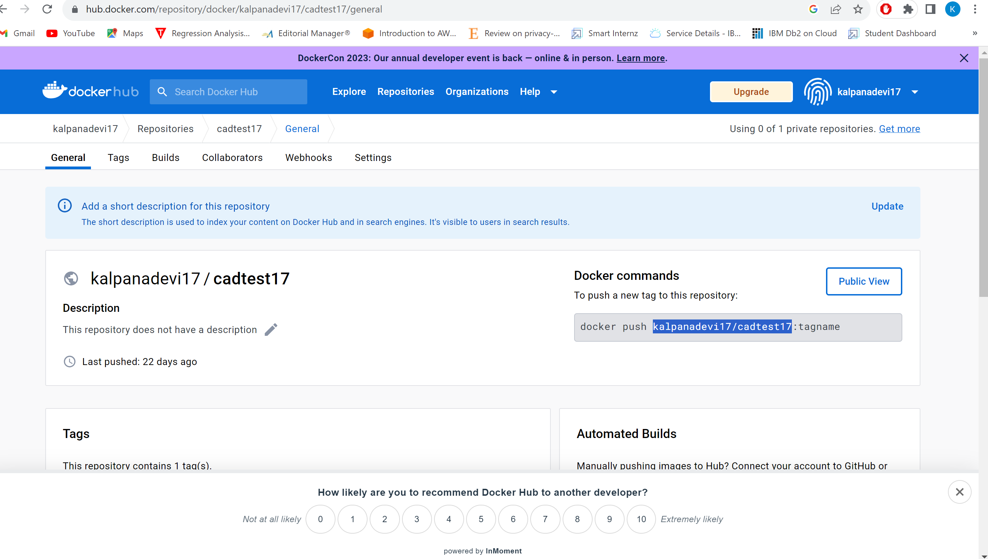

**Github**

GitHub, Inc. is an Internet hosting service for software development and version control using Git. It provides the distributed version control of Git plus access control, bug tracking, software feature requests, task management, continuous integration, and wikis for every project

Phishing all files to GitHUB

To phishing files in to github

Use gitbash:

Git init command :

This is my Git repository link

<https://github.com/smartinternz02/SI-GuidedProject-542472-1692354864>

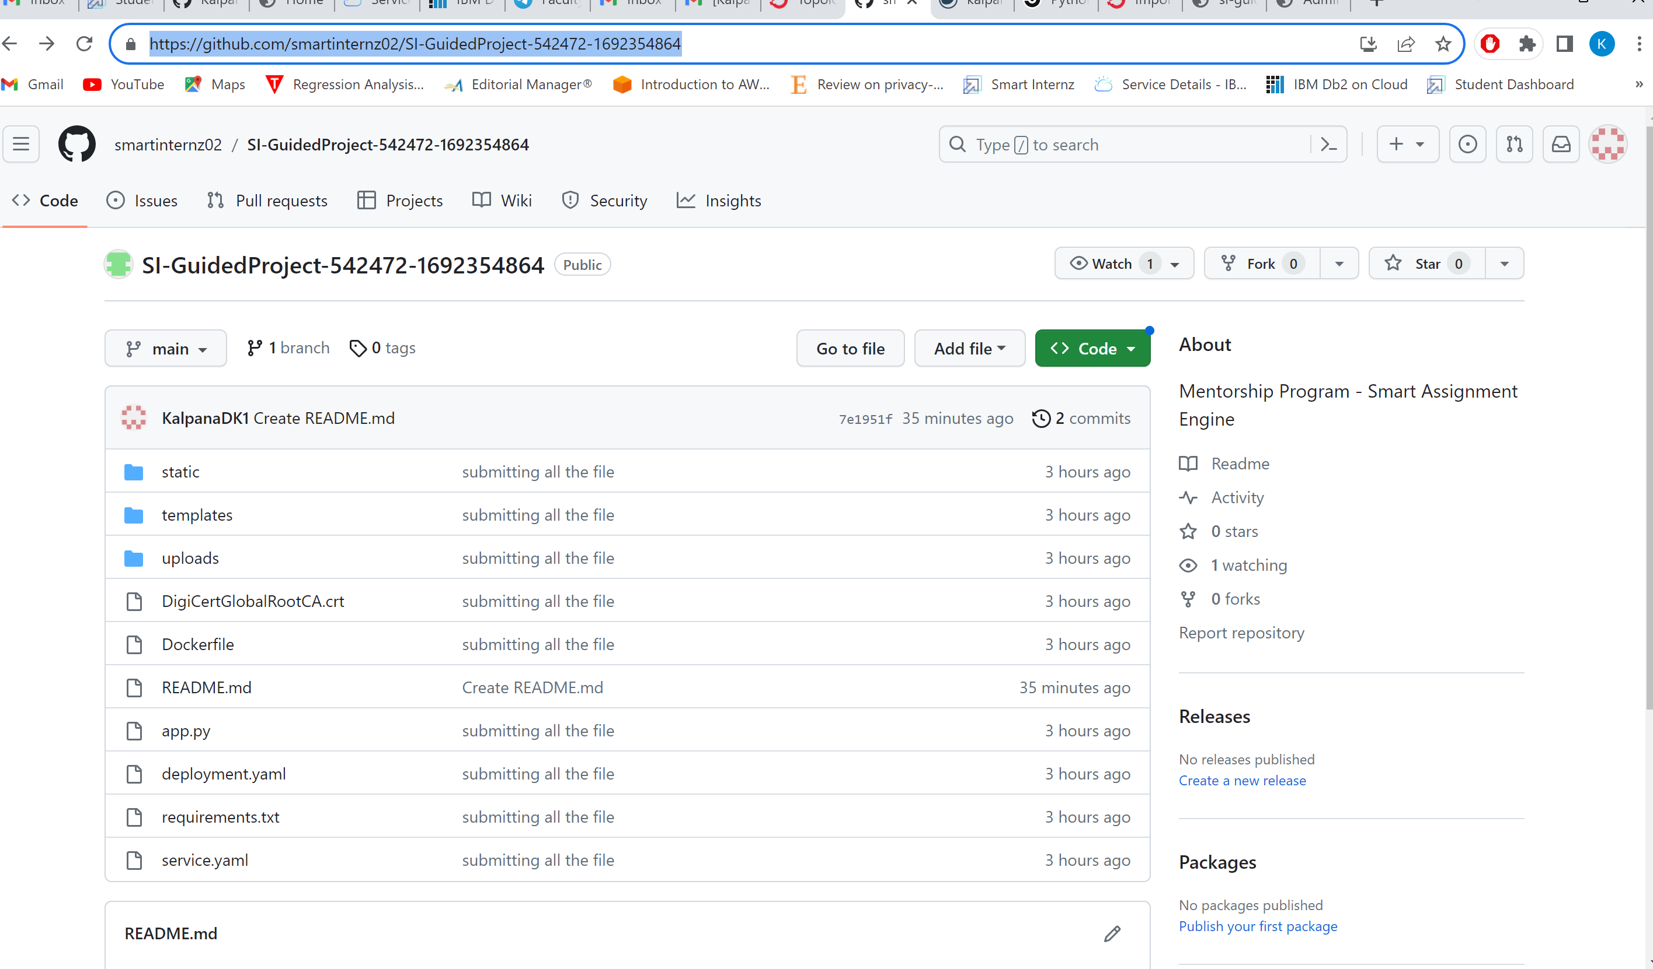

Import the github using Openshift:

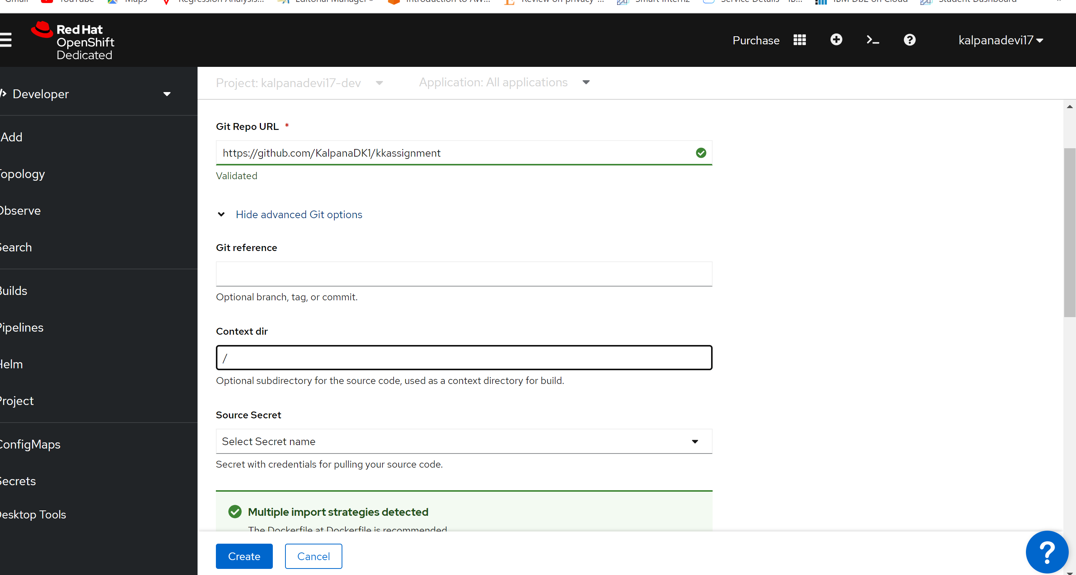

**Kubernetes**

Kubernetes (often abbreviated as "K8s") is an open-source container orchestration system for automating the deployment, scaling, and management of containerized applications. It was originally developed by Google and is now maintained by the Cloud Native Computing Foundation.  
  
Kubernetes also has a rich ecosystem of tools and extensions that can be used to manage and monitor containerized applications, including monitoring, logging, and networking.

Creating YAML file

**Deploying Application In Openshift Using Github**

Click on that import from git option

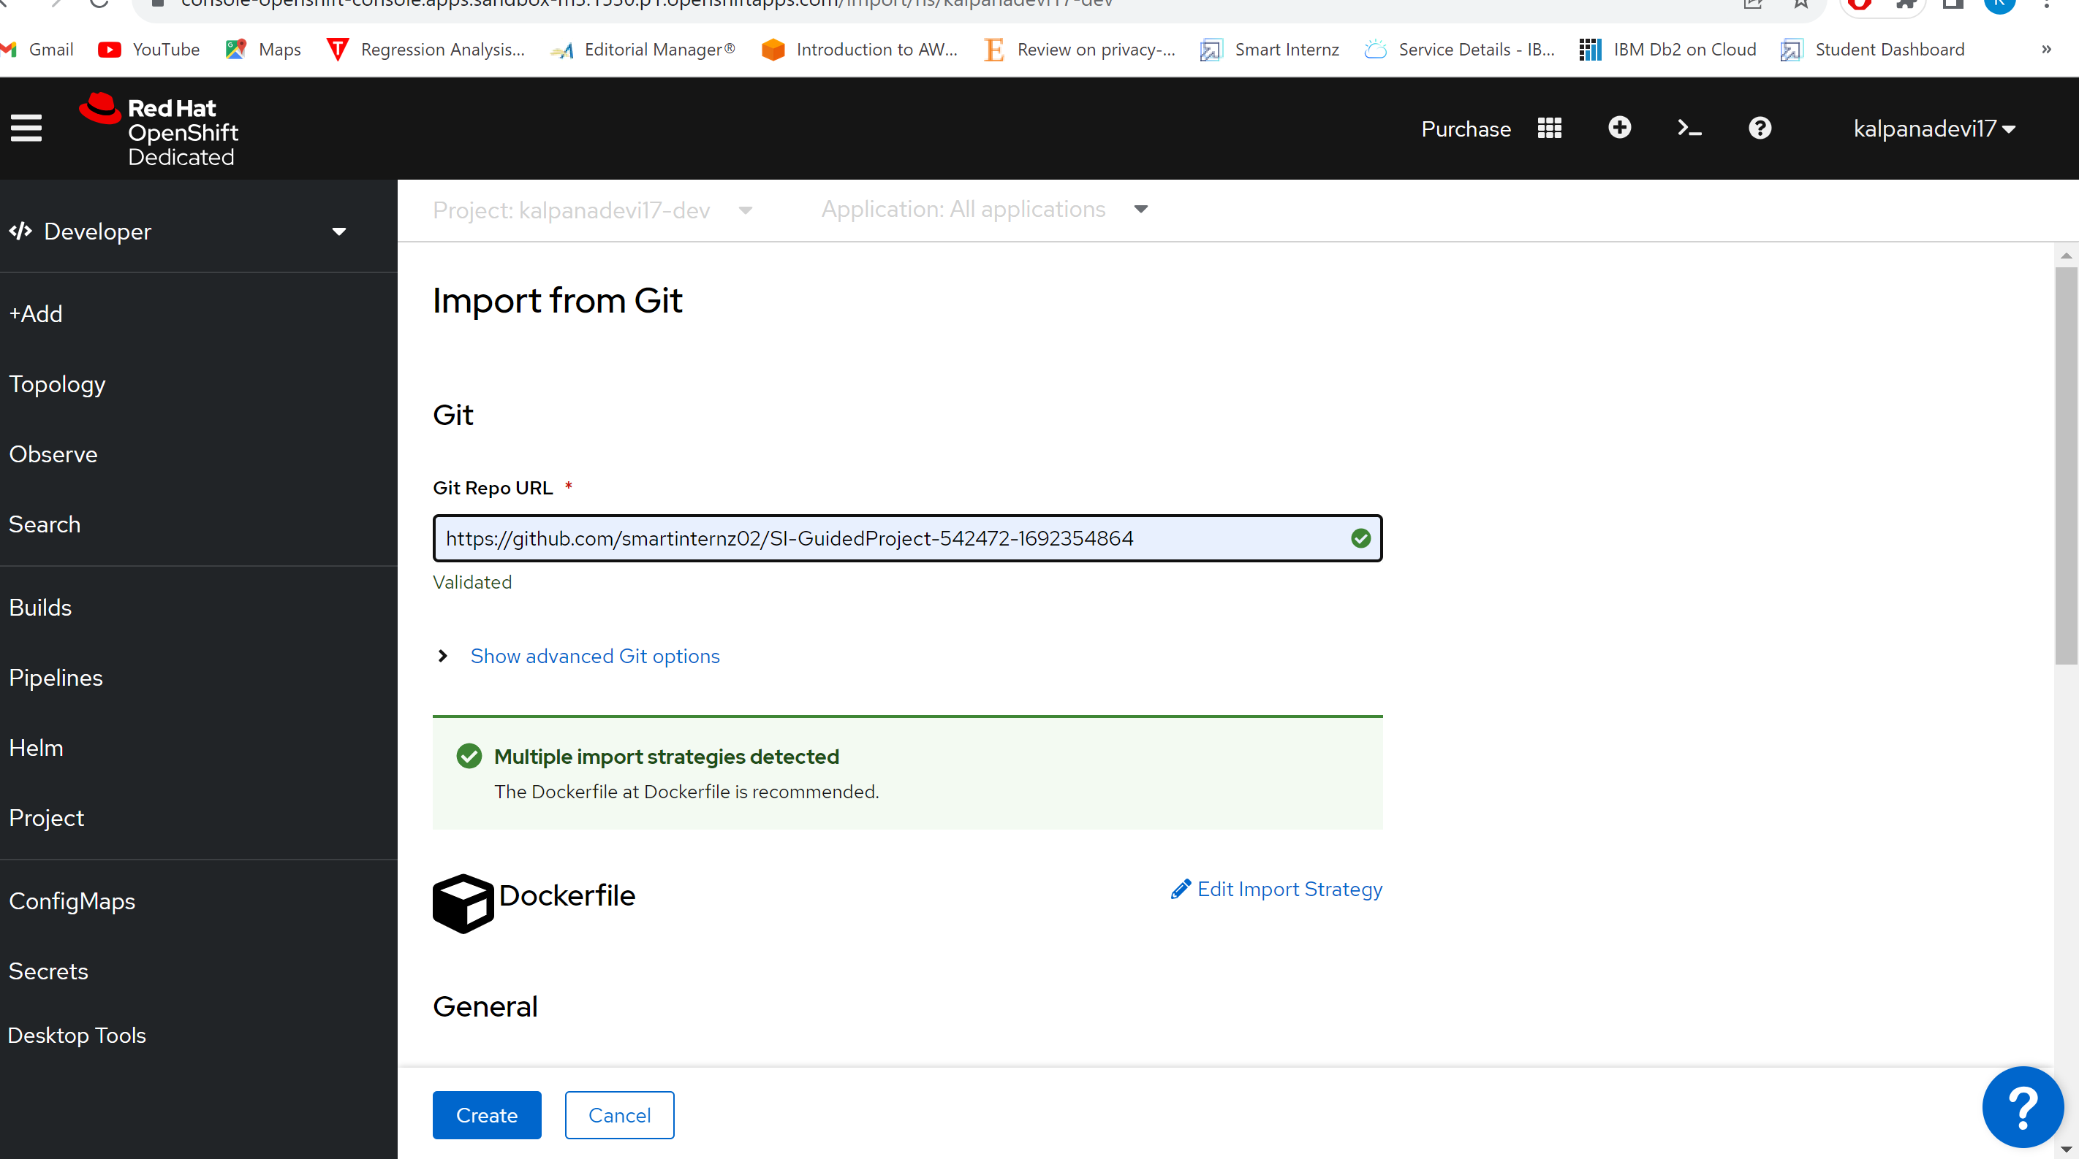

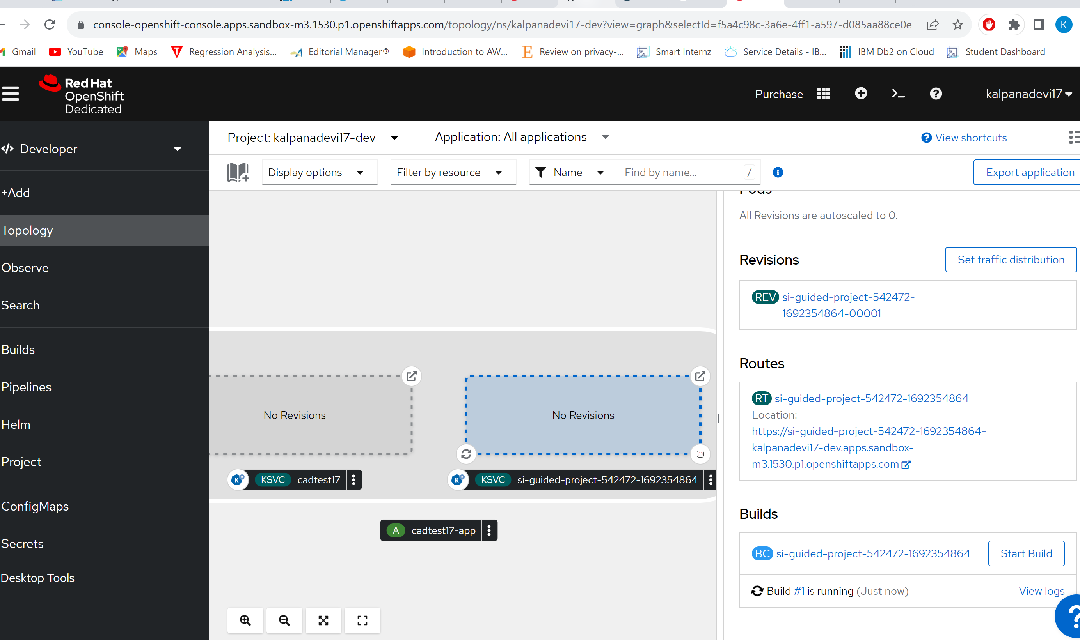

**Deploying Application In Openshift Using Docker Image**

Deploying the application using image is also the same as github, go to that add button on the left side panel and select the container images block.

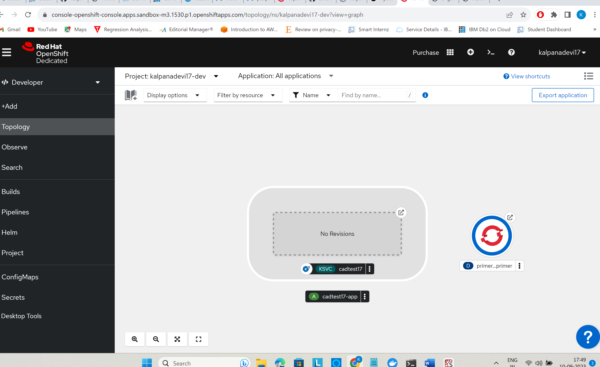

### Deploying Your Application In Openshift Using YAML File

Deploying the application using the Yaml configuration file is also the same as github, go to that add button on the left side panel and select the Import YAML File From Local Machine section.

